|  |  |
| --- | --- |
| Educational Website |  |
| Submitted By : Deepali Mahar , Divanshu Gupta  Reg No. : 12112535, 12105497  Roll No. : RK21GPA44, RK21GPA28  Semester : K21GP  Course code : CSE 326  Submitted to : Dr. Dhanpratap Singh |  |
|  |  |

# CONTENT

|  |  |  |
| --- | --- | --- |
| S NO. | Content | Page No. |
| 1. | Abstract | 3 |
| 2. | Introduction | 4 |
| 3. | Objective | 4 |
| 4. | Conclusion | 9 |
| 5. | GitHub link | 10 |
|  |  |  |

# ABSTRACT

*Online educational resources are tools that can help enhance the learning process and make it more enjoyable for students. These websites can also help make the learning process more interesting and engaging.*

*Unfortunately, there are also some negative aspects to using online educational resources. First, students need to be guided properly. They can also find content that is not up-to-date or does not align with the teaching method. Some websites also have a huge variety of games and resources.*

*The purpose of education website is to provide information on a particular topic to the readers without wasting pages made from tree. In this project, we have made an educational site on child labour in which whole information of how child labour can be prevented, what are organizations working in its betterment, and famous personalities active in this.*

# INTRODUCTION

*Q. What is HTML and CSS?*

*The Hyper Text Markup Language or HTML is the standard*[*markup language*](https://en.wikipedia.org/wiki/Markup_language)*for documents designed to be displayed in a*[*web browser*](https://en.wikipedia.org/wiki/Web_browser)*. It can be assisted by technologies such as*[*Cascading Style Sheets*](https://en.wikipedia.org/wiki/Cascading_Style_Sheets)*(CSS) and*[*scripting languages*](https://en.wikipedia.org/wiki/Scripting_language)*such as*[*JavaScript*](https://en.wikipedia.org/wiki/JavaScript)*.*[*HTML elements*](https://en.wikipedia.org/wiki/HTML_element)*are the building blocks of HTML pages. With HTML constructs,*[*images*](https://en.wikipedia.org/wiki/HTML_element#Images_and_objects)*and other objects such as*[*interactive forms*](https://en.wikipedia.org/wiki/Fieldset)*may be embedded into the rendered page. HTML provides a means to create*[*structured documents*](https://en.wikipedia.org/wiki/Structured_document)*by denoting structural*[*semantics*](https://en.wikipedia.org/wiki/Semantics)*for text such as headings, paragraphs, lists,*[*links*](https://en.wikipedia.org/wiki/Hyperlink)*, quotes and other items. HTML elements are delineated by tags, written using*[*angle brackets*](https://en.wikipedia.org/wiki/Bracket#Angle_brackets)*. HTML can embed programs written in a*[*scripting language*](https://en.wikipedia.org/wiki/Scripting_language)*such as*[*JavaScript*](https://en.wikipedia.org/wiki/JavaScript)*, which affects the behaviour and content of web pages. Inclusion of CSS defines the look and layout of content. The*[*World Wide Web Consortium*](https://en.wikipedia.org/wiki/World_Wide_Web_Consortium)*(W3C), former maintainer of the HTML and current maintainer of the CSS standards, has encouraged the use of CSS over explicit presentational HTML since 1997. A form of HTML, known as*[*HTML5*](https://en.wikipedia.org/wiki/HTML5)*, is used to display video and audio, primarily using the <canvas> element, in collaboration with JavaScript.*

*Cascading Style Sheets (CSS) is a*[*style sheet language*](https://en.wikipedia.org/wiki/Style_sheet_language)*used for describing the*[*presentation*](https://en.wikipedia.org/wiki/Presentation_semantics)*of a document written in a*[*markup language*](https://en.wikipedia.org/wiki/Markup_language)*such as*[*HTML*](https://en.wikipedia.org/wiki/HTML)*. CSS is a cornerstone technology of the*[*World Wide Web*](https://en.wikipedia.org/wiki/World_Wide_Web)*, alongside HTML and*[*JavaScript*](https://en.wikipedia.org/wiki/JavaScript)*.CSS is designed to enable the separation of presentation and content, including*[*layout*](https://en.wikipedia.org/wiki/Page_layout)*, colours, and*[*fonts*](https://en.wikipedia.org/wiki/Typeface)*. This separation can improve content*[*accessibility*](https://en.wikipedia.org/wiki/Accessibility)*; provide more flexibility and control in the specification of presentation characteristics; enable multiple*[*web pages*](https://en.wikipedia.org/wiki/Web_page)*to share formatting by specifying the relevant CSS in a separate .css file, which reduces complexity and repetition in the structural content; and enable the .css file to be*[*cached*](https://en.wikipedia.org/wiki/Cache_(computing))*to improve the page load speed between the pages that share the file and its formatting.*

# OBJECTIVE

The main objective of this project on educational website to educate people of all age groups about ill effects of child labour, how adversely it affects a nation, and how can we prevent it. We made a complete website to provide necessary information regarding child labour. In this, we even mentioned all famous activists who are selflessly giving their services in this noble cause. This project is completely managed by administrators so there so no possible chance that information on this can be morphed.

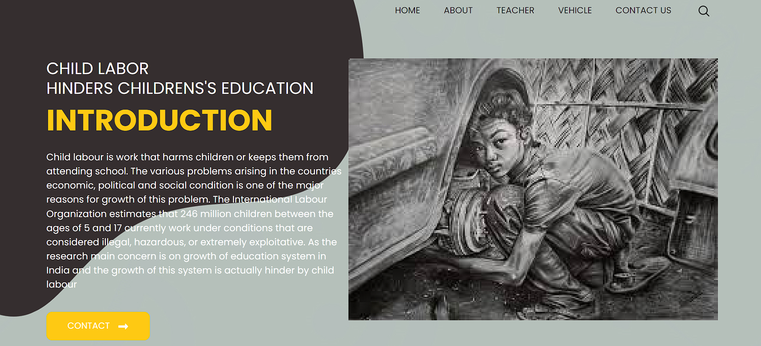

This is the official home page of our website which clearly depicts our motive to let our readers know about our educational website whose topic is CHILD LABOUR. The home carries six various options: Home, About, Teacher, Vehicle, Contact us, Search option.

* *Home page brings users to its initial or we can say our sited home page.*
* *About page provides information regarding history of our constitution which looked in this matter.*
* *Teacher page though sounds weird but we consider our activists as teachers or our role models who are selflessly helping poor children.*
* *Vehicle page showcases all vehicle support that will be provided to safely transport children to safe places.*
* *Contact us page helps users to contact us and provide feedbacks to our team.*
* *Search options helps users surf all available options.*

*Here is a bit explanation of our code;*

*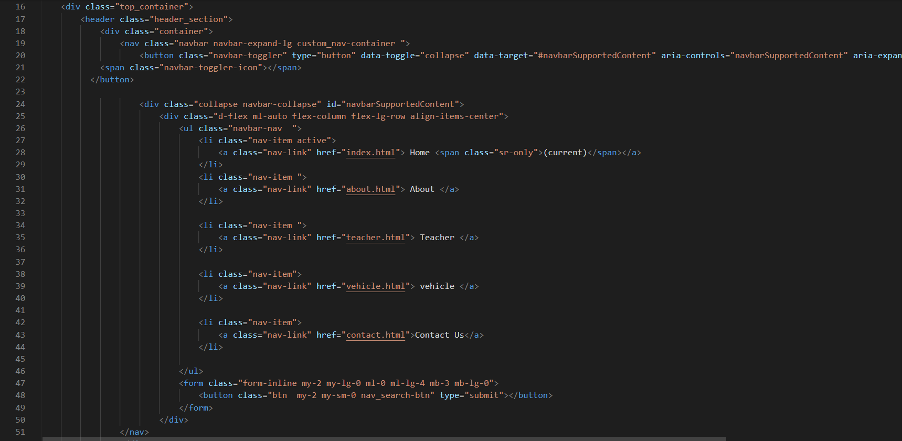1.*

*This part of code shows all different types of quick links available in our website. As mentioned earlier six links are available in our website. It is first part of body of our code*

*2.* 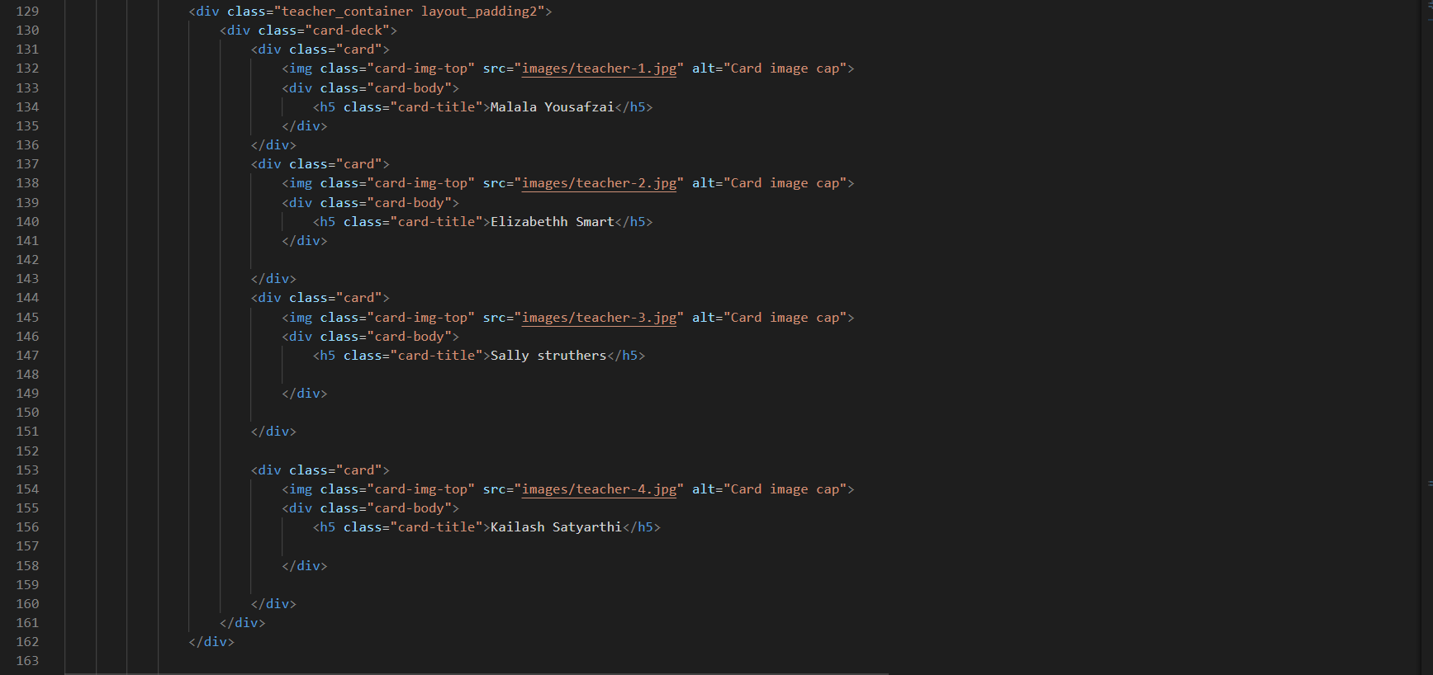

This part of our code displays images our role models or activists. Images are named by teacher 1, teacher2, teacher3, teacher4. Other than this more pictures ragarding child labour is also ouploaded to make oour website look interesting.

*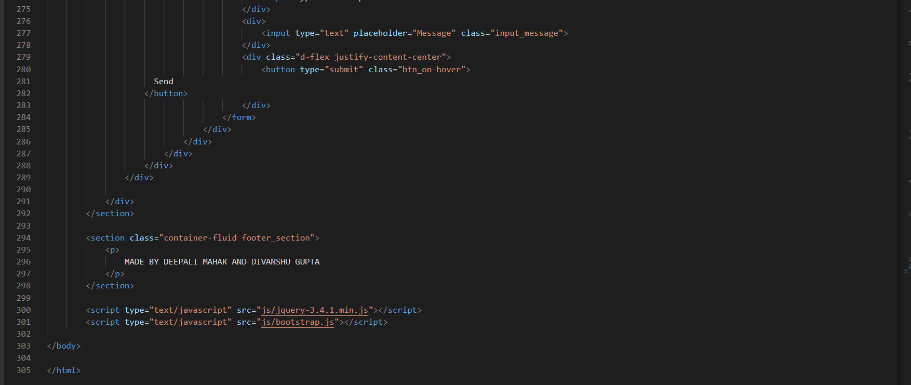3.*

*This part is the last lines of our HTML code. This displays the creators of this project.*

# CONCLUSION

*The emergence of responsive web design, more than six years ago, showed us the vision for our future sites: a world where users can have great experiences no matter what devices or what screen sizes they have those experiences on. However, it was also clear to us that this change was not going to happen without effort—and a tremendous one, at that.  In order to create a well-designed page for a specific audience. The developer needs to organized and analyze the users' statistics and the background of the users. Although it can be hard to come up with a design that is well suited to all of the users, there will be a design that is appropriate for most of the audience.*

# GitHub Link

*https://github.com/herezdivanshu/CSE-326.git*